

***Java Technologies for Web Applications***

**Project Assignment**

|  |  |
| --- | --- |
| Document Code | 25e-BM/HR/HDCV/FSOFT |
| Version | 1.1 |
| Effective Date | 20/11/2012 |

**Hanoi, 04/2019**

RECORD OF CHANGES

|  |  |  |  |  |  |
| --- | --- | --- | --- | --- | --- |
| No | Effective Date | Change Description | Reason | Reviewer | Approver |
|  | 25/Jun/2018 | Create a new assignment | Create new | DieuNT1 | VinhNV |
|  | 01/Jun/2019 | Apply fsoft template  Update requirements: split Specification1 and 2 by training day | Update | DieuNT1 | VinhNV |
|  |  |  |  |  |  |
|  |  |  |  |  |  |
|  |  |  |  |  |  |
|  |  |  |  |  |  |
|  |  |  |  |  |  |
|  |  |  |  |  |  |
|  |  |  |  |  |  |
|  |  |  |  |  |  |

Contents

Project Assignment 4

Objectives 4

Business needs 4

Product architectures 5

Working requirements 5

Technical Requirements 5

Database Relationship 6

Specifications 1 6

Specifications 2 9

Mark scale : 10

|  |  |
| --- | --- |
|  | **CODE: JWEB.P.A101 (CMS)**  **TYPE: Project Assignment**  **LOC: N/A**  **DURATION: 12 hours (completed in 3 working day)** |

# Project Assignment

Objectives

* Understand the basic concepts of web development technologies with java (JSP / Servlet)
* Able to write servlets using the Java programming language (Java servlets)
* Create dynamic HTML content with Servlets and JavaServer Pages, using the Expression Language, and the JSP Standard Tag Library (JSTL)
* Create robust web applications using MVC architecture, session management, filters, and database integration (JDBC) or Hibernate framework
* Make Servlets and JSP work together cleanly
* Create secure web applications using the features of the Java EE web container
* Deploy your project using Apache Tomcat Server

Business needs

Create a Web application based on HTML, CSS, JavaScript, Ajax, JSP/Servlet, JDBC/Hibernate framework to Manage Content System (CMS).

Provide adequate provisions for a special web system. In this assignment, we will learn about a content management system. The use case diagram is described as below:

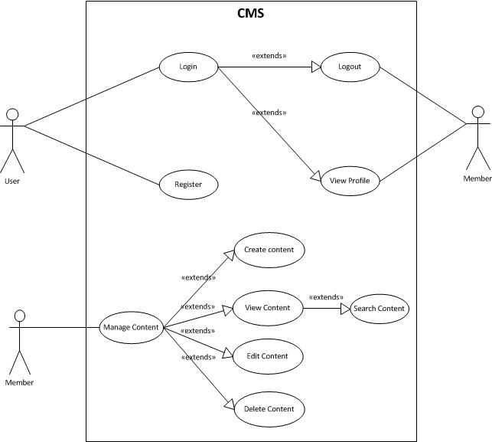

A content management is a computer application that supports the creation and modification of digital content using a simple interface to abstract away low-level details unless required, usually supporting multiple users working in a collaborative environment.

CMS features vary widely. Most CMSes include Web-based publishing, format management, history editing and version control, indexing, search, and retrieval. By their nature, content management systems support the separation of content and presentation.

Product architectures

If you use JDBC to connect to Database, then must use the following architecture:



The architecture with Hibernate framework:

**Model/Value objects**

*(represent things in our application domain)*

**Data access layer**

*(handle saving and retrieving data as objects)*

**Presentation Layer**

*(This layer controls the display to the end user)*

HibernateUtils

**Database**

Client tier

Working requirements

Working environment:

* Eclipse IDE,
* SQL DB Server,
* Apache TomCat 8 or later,
* Internet connection,
* Apache Maven.

Delivery:

* Source code, deployment and testing evident packaged in a compress archive.

Technical Requirements

* Must use HTML/CSS, JS/jQuery, JSP/Servlet and JDBC or Hibnerate Framework

Database Relationship

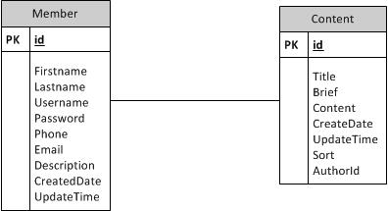

* Member stores the user information, including username and password.
* Content stores the post content information. Each comment is associated with a post and mainly consists of the following columns:
  + authorID: required, the author id;
  + Title: required, the title of the content;
  + Brief: required, it is the description of content;
  + Content: required, the comment content in plain text format.
  + Sort: option, it use to other the post in the list.
  + CreateDate, UpdateTime are date time create and update this post.

Specifications 1

You have to create the 5 .jsp pages for a CMS (Content Management System), the design for each page is as below:

* *Login page*

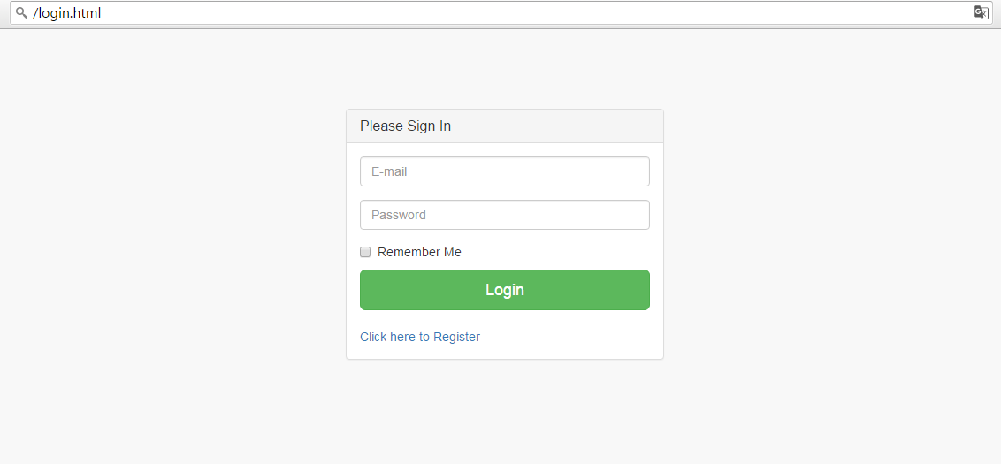

List item definition for Login page:

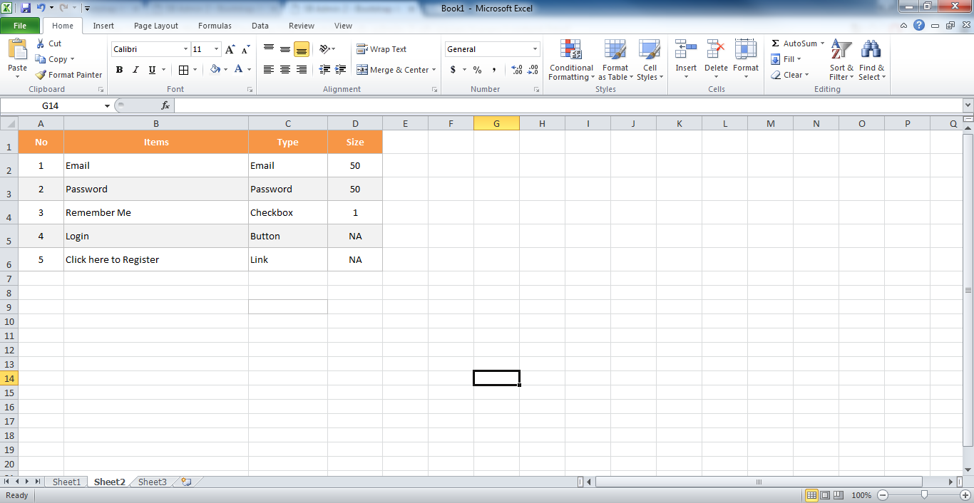

* *Register page*

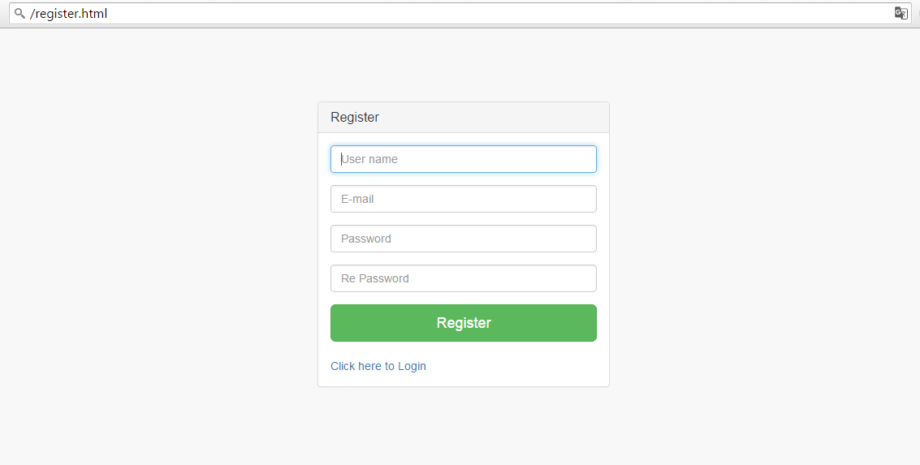

List item definition:

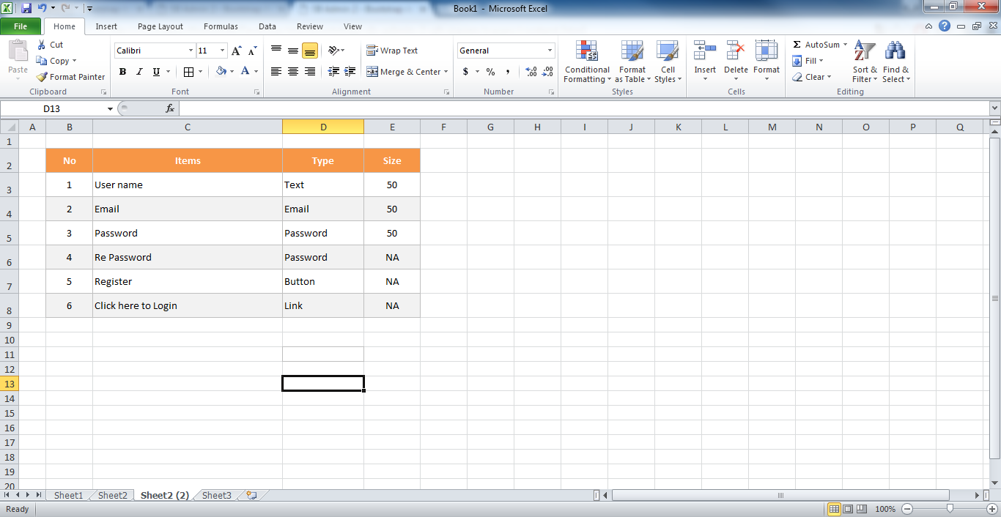

* *Edit Profile*

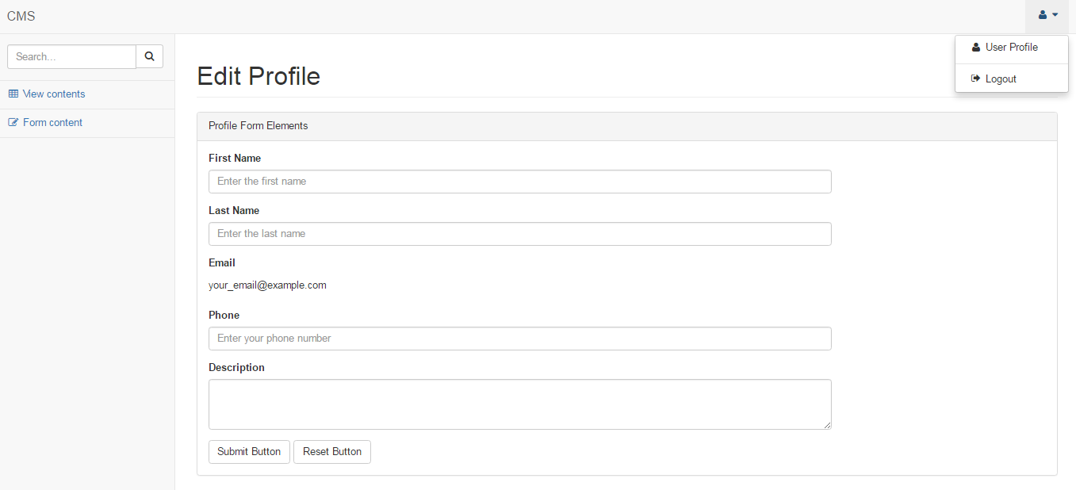

List item definition:

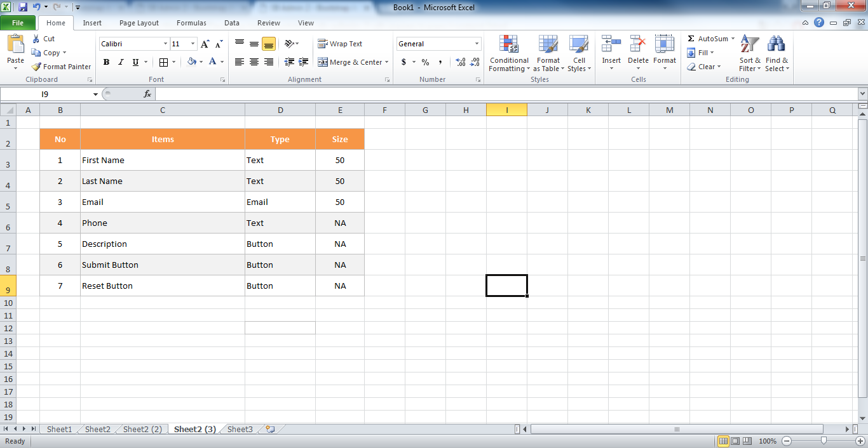

* *Form content*

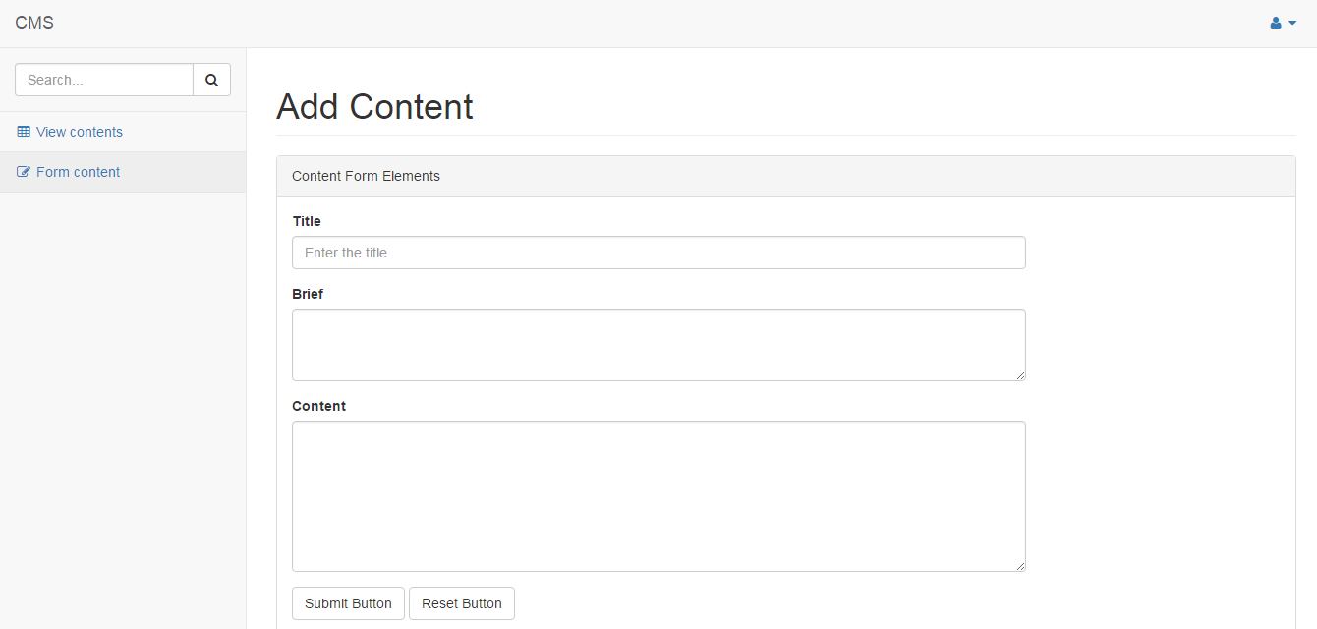

List item definition:

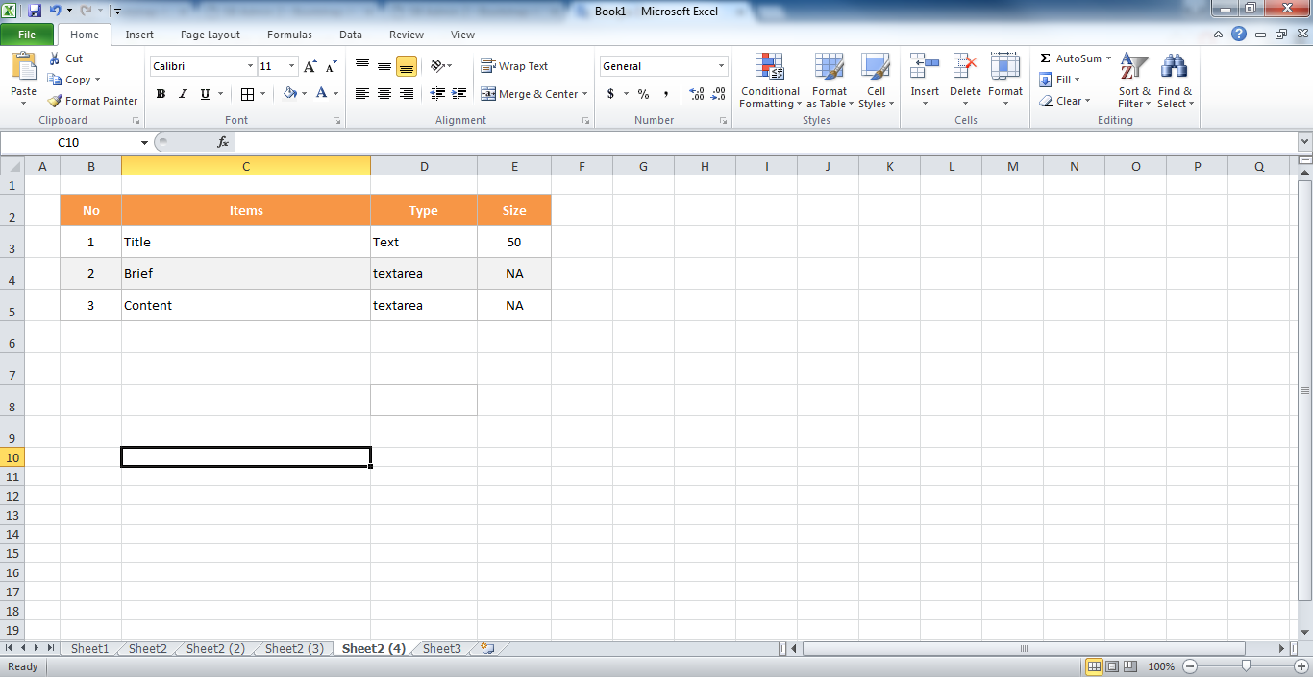

* *View contents*

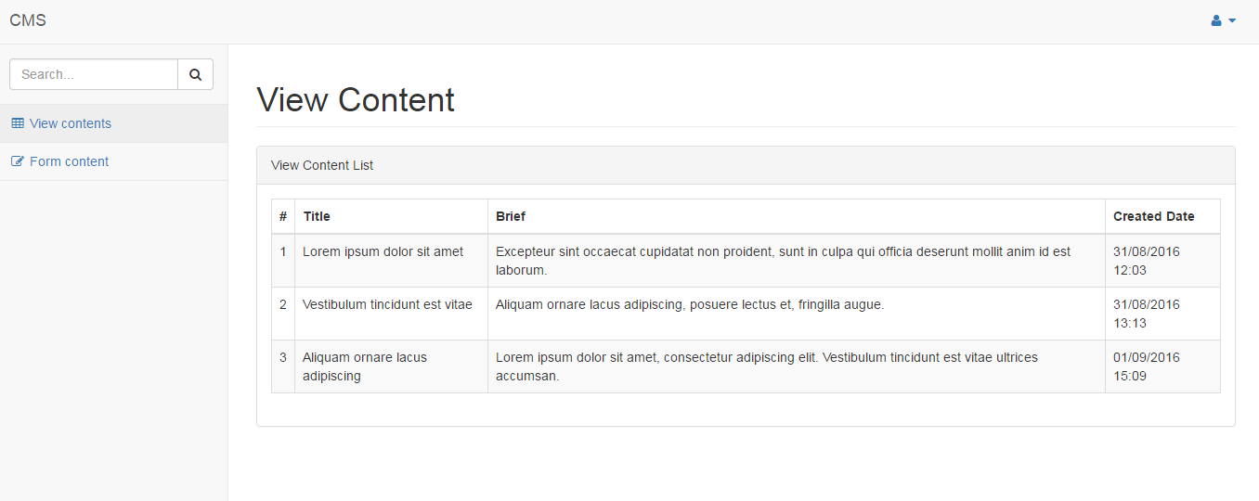

Index page will use Ajax/jQuery to load data from servlet.

In this assignment, you must finish the feature in use case as below:

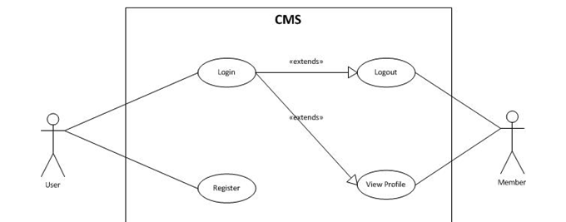

The authentication and authorized user use Case:

* Use form-based authentication with a basic servlet. With form-based authentication, you can customize the login screen and error pages that are presented to the web client for authentication of their user name and password.
* When a user submits their name and password, the server determines if the user name and password are those of an authorized user and, if authorized, will move the user to the screen view his/her profile.

**Request to Answer:**

* All pages will run on the Tomcat server.
* In this assignment, you will create a program that allows a user to do the login using user and password if existed account in DB. Otherwise, the user must complete the registration via a Register page.
* In Register Page, you will insert user information to database.
  + ID column is a primary key column
  + The columns “CreateDate” and “UpdateTime” are automatically increases the value by current date and time.
* The registration page should be displayed when a user clicks on the register command button in the login page. After register success, you will navigate to Login Page.
* In Edit Profile Page, you will update some information of user.
* User need use java code to validate data before insert, update user information to database. So that, we was validated data on client by Javascript and you will validate by Java on server.
* Deploy your application into Tomcat server.

Specifications 2

In this specification of assignment, you must to finish all feature in bellow Use case:



You must implement a program that manages Content and it will follow the above use case.

* The columns “CreateDate” and “UpdateTime” are automatically increases the value by current date and time.
* ID column is a primary key column

View Content and Search content page will be use Ajax/jQuery to load data from servlet.

* User need use java code to validate data before insert, update user information to the database. So that, we were validated data on the client by Javascript and you will validate by Java on the server.

Mark scale :

|  |  |
| --- | --- |
| * Create project with architectures, Configuration, Mapping : 20% * Specification 1 : 30% | * Specification 2 : 40% * Non-Functional, Quality requirements: 10% |

**-- THE END --**